MITCHAM PRIMARY SCHOOL

Volunteer Occupational Health and Safety (OHS) Induction Handbook

Prepared by: | C. FUHRMANN
Date Prepared: | 24/08/2023
Date of Review: | 20/03/2025 | Date of next review: 20/03/2026

Table of Contents

Table of Contents 2
Introduction 1
Department Health, Safety and Wellbeing (HSW) Policy 2
Required conduct/behaviour 3
Access arrangements 4
Access 4
Traffic Management 4
OHS Induction 5
Site specific hazards 6
Asbestos 6
Hazardous Substances and Dangerous Goods 6
Animals/Wildlife 6
Emergency Management 7
Workplace Codes Error! Bookmark not defined.
Emergency Procedures 7
Leaving Site in an Emergency 7
Evacuation Point 7
Emergency Contacts 8
First Aid 9
First Aid 9
Error! Bookmark not defined.
Hazard and Incident Reporting 10
Appendix A: Emergency Evacuation Map 11

Introduction
To comply with the requirements of the Victorian Occupational Health and Safety (OHS) Act 2004 and the Victorian OHS Regulations 2017 the Department of Education (the Department) has implemented an OHS Management System (OHSMS) in all Victorian Government schools.
The OHSMS requires all volunteers to:
- report to the general office or designated site contact upon arrival at site
- complete an OHS induction using the Volunteer OHS Induction Checklist
- sign in and out and ensure their visitors pass is worn at all times whilst on Department or other premises
- have a current Working with Children Check, where applicable.

Department Health, Safety and Wellbeing (HSW) Policy
The Department has the Health, Safety and Wellbeing Policy, which has been endorsed by the Department Secretary and can be seen below:
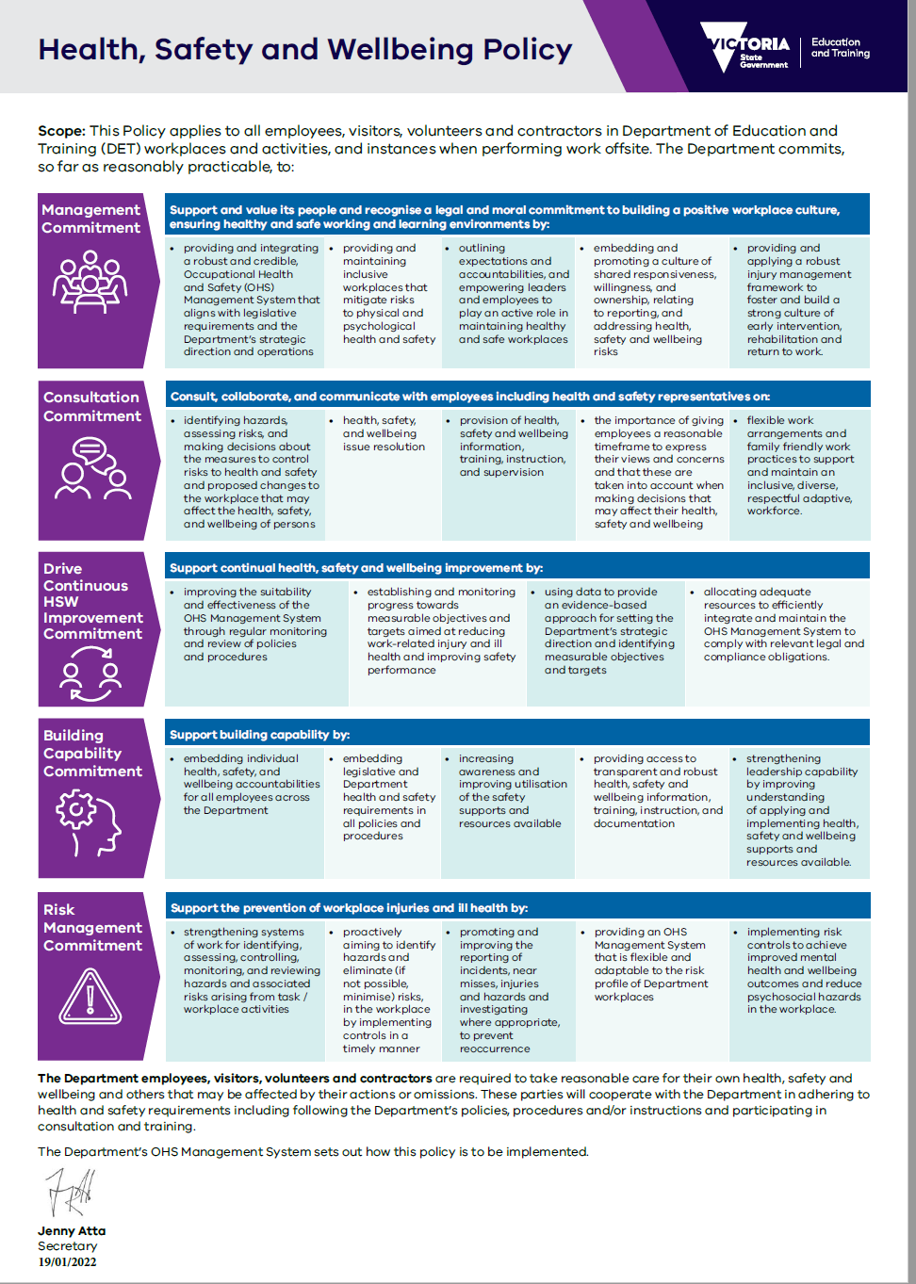

Required conduct/behaviour
All volunteers are expected to abide by the workplaces code of conduct while on site.
This includes:
- No smoking on school grounds or within four metres of an entrance to all Department workplaces.
- No alcohol or drugs are to be consumed on any Department premises. Any volunteer under the influence will be dismissed.
- No offensive language is permitted on any Department premises.
- Noise must be kept to a minimum. If this is not practicable, then non-urgent work should be scheduled outside of school hours, where possible.
- Possessions, materials, and equipment should be secured and not left unattended.
- Abide by the workplaces traffic management procedures.
- Entrance to other areas of the Department workplace aside from the work area is prohibited, unless otherwise agreed to.
- Remove all litter and debris from the workplace.
- Report any problems, hazards, or incidents to the principal or their delegate.
- Dress appropriately and wear the correct personal protective equipment suitable.
- No pets are permitted on Department premises.

Access arrangements

Access
All volunteers must report to the general office or site contact and sign in upon arrival at the workplace or designated point where not on Department premises. This requirement is indicated on signage located at all entrances to the school, see below:
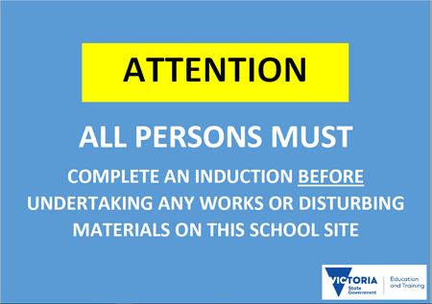

Traffic Management
Volunteers driving vehicles are to enter and exit the school grounds via the following locations:
- Bowling Green Lane (Car Park Entry)
- Tirana Street
Designated pedestrian crossings are:
- Mitcham Road, Springfield Road and Tirana Street
Vehicles entering school grounds must adhere to all traffic signage. Where there is no signage, vehicles are to move at walking pace at all times. If a vehicle has limited visibility or mobility, a spotter should be used when the vehicle is in motion.
Volunteers are not to operate vehicles on, or around, school grounds during designated drop off/pick up times or during break times:

- Drop off: 8:30am – 8:45am. School starts at 8;45am
- Recess: 11:15am – 11:45am
- Lunch (outside): 1:35pm – 2:25pm
- Pick up: 3:00pm – 3:30pm School ends at 3:15pm

OHS Induction
Upon arrival at the site, you will be required to complete an OHS Induction covering the site-specific risks.
The volunteer OHS induction is valid for 12 months.
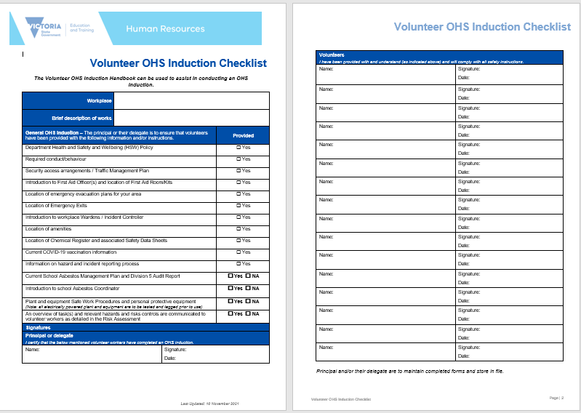

Site specific hazards

Asbestos
All schools are expected to have a Schools Asbestos Management Plan in the event of the discovery of suspected asbestos containing material (ACM) or the accidental disturbance of existing ACM.
If ACM has been identified in the school, the following process must be followed prior to the commencement of works:
- Asbestos Register MUST be checked at the time of sign-in when the proposed work involves drilling, scraping, sanding, sawing or any other destructive process.
- if work is to be carried out in the vicinity of Asbestos Containing Material, the Asbestos Coordinator Michelle Shearn on 03 9873 1551 must be consulted prior to the commencement of work.
- asbestos containing material may only be removed by a licensed removalist.

Hazardous Substances and Dangerous Goods
If transporting hazardous substances or dangerous goods onto site, the principal or their delegate must be informed. You must complete a Safe Work Method Statement or equivalent to outline the controls methods you will use to ensure that the risks of the hazardous substances and/or dangerous goods are managed.
Such controls may include, but are not limited to:
- the provision of Safety Data Sheets (SDS)
- correct labelling of containers
- correct storing and handling of containers
- correct disposal of any waste
- provision of personal protective equipment (PPE).

Animals/Wildlife
There is the potential to come into contact with domestic animals and wildlife while on this site. Should this occur, you must:
- do not approach any domestic animals (e.g., dogs) or dangerous wildlife
- report the sighting of any domestic animals or dangerous wildlife to the principal or their delegate
- do not reach into any holes or gaps in the buildings without first checking to see if it is safe.

Emergency Management

Emergency Procedures
On hearing the alarm:
  - switch off all equipment
  - proceed to the advised assembly area
  - report to one of the wardens
  - do not leave the assembly area until advised.

Leaving Site in an Emergency
All volunteers are required to proceed to the evacuation point and remain there until given clearance to leave by the Incident Controller or principal or their delegate.

Evacuation Point
The evacuation point is located at BASKETBALL COURTS, BOWLING GREEN LANE refer to Evacuation Map (Appendix A).

Emergency Contacts
School contacts
Workplace Manager | ERIN NORMAN | 03 9873 1551
Asbestos Co-ordinator | ADRIAN SHEARN | 03 9873 1551
Business Manager | MICHELLE SHEARN | 03 9873 1551
General Office Number |  | 03 9873 1551

Emergency contacts
Police: | 000
Fire: | 000
Ambulance: | 000
Poisons: | 13 11 26

First Aid

First Aid
In the event of an injury:
- if the injury is not serious, report or escort the injured party to the administration office for assistance
- if the injury is serious ring 000, do not wait for first aid officer
- stay with injured party. Send someone else to find the first aid officer or workplace manager
- if no one else is available, ring the school number and inform the office that someone is injured at your location
- if trained, apply first aid to the injured party
- once incident is over, fill in an incident report at the office.

Hazard and Incident Reporting
Any hazard or incident that poses a risk to the safety of a student, parent, visitor, volunteer or employee must be reported.
- Call 000 immediately to report any incident threatening life or property. This number will connect you to the following emergency services:
  - police for crime, injury that may not be accidental, or assault
  - ambulance for injury and medical assistance
  - fire brigade for fires, gas leaks and incidents involving hazardous and dangerous materials.
- Notify the administration office in person, or, if unable or unsafe to do so, notify someone via the emergency contact list.
- Principal to report the incident on eduSafe Plus.

Appendix A: Emergency Evacuation Map

